**BED CA1 Documentation**

**Name:** Ng Jun Han

**Admin No:** 2008493

**Class:** DISM/2B/21

Table of Contents

Installation 4

Database Schema Design 4

Webservice Validation 5

Endpoint 1 - POST /users 5

Success Response 5

Error Response(s) 5

Endpoint 2 - GET /users 7

Success Response 7

Error Response(s) 7

Endpoint 3 - GET /users/:id 8

Success Response 8

Error Response(s) 8

Endpoint 4 - PUT /users/:id 9

Success Response 9

Error Response(s) 9

Endpoint 5 - POST /airport 10

Success Response 10

Error Response(s) 10

Endpoint 6 - GET /airport 11

Success Response 11

Error Response(s) 11

Endpoint 7 - POST /flight 12

Success Response 12

Error Response(s) 12

Endpoint 8 - GET /flightDirect/:originAirportId/:destinationAirportId 13

Success Response 13

Error Response(s) 13

Endpoint 9 - POST /booking/:userid/:flighted 14

Success Response 14

Error Response(s) 14

Endpoint 10 - DELETE /flight/:id 15

Success Response 15

Error Response(s) 15

Endpoint 11 - GET /transfer/flight/:originAirportId/:destinationAirportId 16

Success Response 16

Error Response(s) 16

Advanced Features 16

File Uploading and Storage 16

Promotion Endpoints 17

Endpoint 12 - POST /promotion 17

Endpoint 13 - GET /promotion 18

Endpoint 14 - DELETE /promotion/:id 19

Endpoint 15 - GET /promotion/flight/:flighted 20

Endpoint 16 - POST /promotion/:promotionid/flight/:flighted 21

Endpoint 17 - DELETE /promotion/flight/:flighted 22

Review Endpoints 23

Endpoint 18 - POST /review/:flightid/:userid 23

Endpoint 19 - GET /review/:flightid 24

Additional Endpoints 25

GET /flight (all flights) 25

Success Response 25

Error Response(s) 25

# Installation

* Open the zip and extract all the files
* Copy the db_init.sql and run it on SQL query on Workbench
* In databaseConfig.js, change the password to your password that is used on workbench
* Run `npm install` to install all required node packages.
* Run `node server.js ` on your terminal.
* Refer to README.md for more information about the code

# Database Schema Design

# Webservice Validation

## Endpoint 1 - POST /users

### Success Response

For the profile_pic_url, if no file is provided, it would give a default profile picture, ‘./img/default.png’.

The file will be moved and stored in the /img directory while creating and storing a link on the SQL database.

### Error Response(s)

**Condition: The new username OR new email provided already exists**

Code: 422 Unprocessable Entity

**Condition: Input file is not a jpg or png image below 1MB**

Code: 400 Bad Request

**Unknown Error**

Code: 500 Internal Server Error

## Endpoint 2 - GET /users

### Success Response

### Error Response(s)

**Condition: No users within the database**

Code: 200 OK (the reason is that the database is functional)

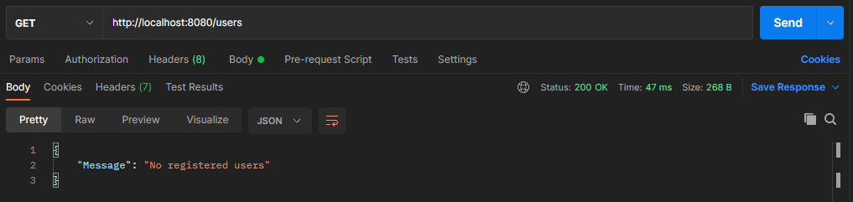

**Unknown Error**

Code: 500 Internal Server Error

## Endpoint 3 - GET /users/:id

### Success Response

### Error Response(s)

**Condition: User not found in database**

Code: 404 Not Found

**Unknown Error**

Code: 500 Internal Server Error

## Endpoint 4 - PUT /users/:id

### Success Response

### Error Response(s)

**Condition: User not in database**

Code: 404 Not Found

**Condition: The new username OR new email provided already exists.**

**(Additional Condition: If user_id != 1 AND role = Admin)**

Code: 422 Unprocessable Entity

**Unknown Error**

Code: 500 Internal Server Error

## Endpoint 5 - POST /airport

### Success Response

### Error Response(s)

**Condition: The airport name provided already exists**

Code: 422 Unprocessable Entity

**Unknown Error**

Code: 500 Internal Server Error

## Endpoint 6 - GET /airport

### Success Response

### Error Response(s)

## Endpoint 7 - POST /flight

### Success Response

### Error Response(s)

**Unknown Error**

Code: 500 Internal Error

## Endpoint 8 - GET /flightDirect/:originAirportId/:destinationAirportId

### Success Response

### Error Response(s)

**Condition: No flights for the given flight directions**

Code: 404 Not Found

**Unknown Error**

Code: 500 Internal Server Error

## Endpoint 9 - POST /booking/:userid/:flighted

### Success Response

### Error Response(s)

**Unknown Error**

Code: 500 Internal Server Error

## Endpoint 10 - DELETE /flight/:id

### Success Response

### Error Response(s)

**Unknown Error**

Code: 500 Internal Server Error

## Endpoint 11 - GET /transfer/flight/:originAirportId/:destinationAirportId

### Success Response

### Error Response(s)

**Unknown Error**

Code: 500 Internal Server Error

# Advanced Features

## File Uploading and Storage

* Imported express-fileupload for image uploading.
* Image.js contained the checker to only allow **jpg** OR **png** with a 1MB file size limit.
* All uploaded pictures are stored and can be viewed inside the ‘img’ folder included the submission.
* For file uploading and storage, it has been integrated into the POST and PUT for /users. Please refer to Endpoint 1 – POST /users and Endpoint 4 – PUT /users/:id for their respective success and error responses.

## Promotion Endpoints

## Endpoint 12 - POST /promotion

Success Response

Error Response(s)

**Condition: Promotion already exist in database**

Code: 422 Unprocessable Entity

**Condition: Start Date is after End Date**

Code: 400 Bad Request

**Unknown Error**

Code: 500 Internal Server Error

## Endpoint 13 - GET /promotion

Success Response

Promotions are arranged in order from the upcoming promotion to the last inputted promotion

Error Response(s)

**Unknown Error**

Code: 500 Internal Server Error

## Endpoint 14 - DELETE /promotion/:id

Success Response

Error Response(s)

**Unknown Error**

Code: 500 Internal Server Error

## Endpoint 15 - GET /promotion/flight/:flighted

Success Response

Error Response(s)

**Unknown Error**

Code: 500 Internal Server Error

## Endpoint 16 - POST /promotion/:promotionid/flight/:flighted

Success Response

Error Response(s)

**Condition: Promotion is already in database**

Code: 422 Unprocessable Entity

**Condition: Flight not within promotional period**

Code: 400 Bad Request

**Unknown Error**

Code: 500 Internal Server Error

## Endpoint 17 - DELETE /promotion/flight/:flighted

Success Response

Error Response(s)

**Unknown Error**

Code: 500 Internal Server Error

## Review Endpoints

## Endpoint 18 - POST /review/:flightid/:userid

Success Response

Error Response(s)

**Unknown Error**

Code: 500 Internal Server Error

## Endpoint 19 - GET /review/:flightid

Success Response

Error Response(s)

**Condition: No reviews**

Code: 404 Not Found

**Unknown Error**

Code: 500 Internal Server Error

## Additional Endpoints

I added some additional endpoints for quality-of-life when moving to a website, such as get all flights, where the user can search for a list of all available flights’ w/o any filters.

## Endpoint 20 - GET /flight (all flights)

### Success Response

### Error Response(s)

**Unknown Error**

Code: 500 Internal Server Error

